**Experiment 5: Implementation of Bus topology**

**Steps to Configure and Setup Bus Topology:**

**Step 1:** First, open the cisco packet tracer desktop and select the devices given below:

| **S.NO** | **Device** | **Model-Name** |
| --- | --- | --- |
| **1.** | PC | PC |
| **2.** | Switch | PT-Switch |

| **S.NO** | **Device** | **IPv4 Address** | **Subnet Mask** |
| --- | --- | --- | --- |
|  | **pc0** | 192.168.0.1 | 255.255.255.0 |
|  | **pc1** | 192.168.0.2 | 255.255.255.0 |
|  | **pc2** | 192.168.0.3 | 255.255.255.0 |
|  | **pc3** | 192.168.0.4 | 255.255.255.0 |

* Then, create a network topology as shown below image:
* Use an Automatic connecting cable to connect the devices with others.

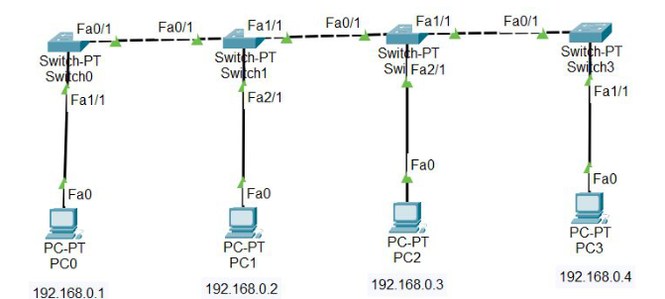

**Step 2:** Configure the PCs (hosts) with IPv4 address and Subnet Mask according to the IP addressing table given above.

* To assign an IP address in PC0, click on PC0.
* Then, go to desktop and then IP configuration and there you will IPv4 configuration.
* Fill IPv4 address and subnet mask.

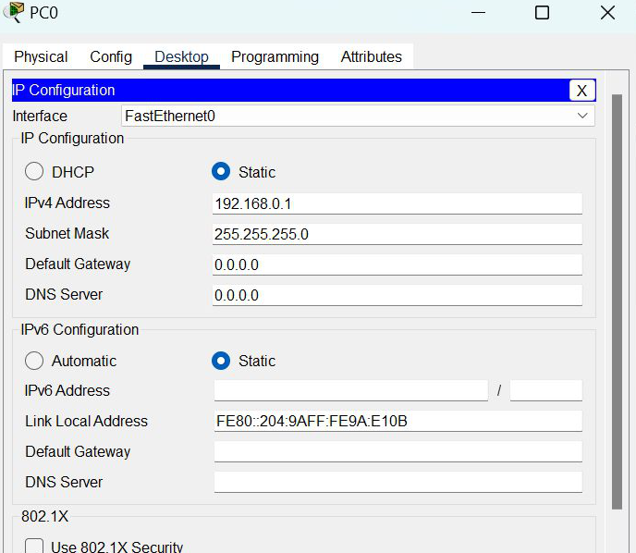

* Assigning an IP address using the ipconfig command, or we can also assign an IP address with the help of a command.
* Go to the command terminal of the PC.
* Then, type ipconfig <IPv4 address><subnet mask><default gateway>(if needed)

Example: ipconfig 192.168.0.1 255.255.255.0

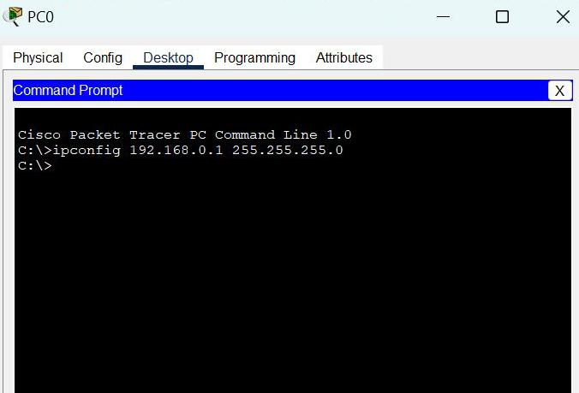

* Repeat the same procedure with other PCs to configure them thoroughly.

**Step 3:** Verify the connection by pinging the IP address of any host in PC0.

* Use the ping command to verify the connection.
* As we can see we are getting replies from a targeted node on both PCs.
* Hence the connection is verified.

